## **DATE:**

## **EXPERIMENT:14**

## **SIMULATING X, Y, Z COMPANY NETWORK DESIGN AND SIMULATE USING PACKET TRACER**

**Aim:** To simulate X,Y,Z company network design and stimulate using packet tracer.

**Software/Apparatus required:** Packet Tracer/End devices, Hubs, connectors.

**Algorithm:**

1. Identify the network requirements: Determine the number of users, devices, and servers that will be connected to the network.
2. Create a network diagram: Use a network diagramming tool to create a visual representation of the network design, including the devices, servers, switches, routers, and connections.
3. Configure the routers: Configure the routers with IP addresses, subnet masks, and routing protocols as needed.
4. Configure the switches: Configure the switches with VLANs, and assign ports to each VLAN. 5. Configure the servers: Configure the servers with IP addresses, subnet masks, and any necessary applications or services.
5. Configure the workstations: Configure the workstations with IP addresses, subnet masks, and any necessary applications or services.
6. Configure security: Configure security measures such as firewalls, access control lists, and intrusion detection systems as needed.
7. Test the network: Test the network connectivity by pinging devices and verifying that data can be transmitted between them.
8. Monitor network traffic: Use Packet Tracer's built-in network monitoring tools to monitor network traffic and identify any potential issues.
9. Make adjustments as needed: Make adjustments to the network configuration as needed to improve performance, security, or functionality.

**Procedure:**

1. Start Packet Tracer: Launch Packet Tracer on your computer.
2. Create a new project: Click on "File" and select "New", then select "Network" from the options. 3. Add devices: Click on the "Devices" tab in the bottom-left corner of the window, and drag and drop devices onto the workspace. Add devices such as routers, switches, servers, and workstations. 4. Connect devices: Use the "Cable" tool to connect the devices together. Configure the connections as needed.
3. Configure devices: Double-click on each device to open its configuration menu, and configure its settings such as IP address, subnet mask, and routing protocols. Configure security measures such as firewalls, access control lists, and intrusion detection systems as needed.
4. Add applications: Click on the "Applications" tab in the bottom-left corner of the window, and drag and drop applications onto the workstations and servers. Configure the applications as needed.
5. Test the network: Use Packet Tracer's built-in testing tools to verify that the network is working correctly. Test the network connectivity by pinging devices and verifying that data can be transmitted between them.
6. Monitor network traffic: Use Packet Tracer's built-in network monitoring tools to monitor network traffic and identify any potential issues.
7. Make adjustments as needed: Make adjustments to the network configuration as needed to improve performance, security, or functionality.
8. Save the project: Click on "File" and select "Save" to save the project.

**OUTPUT:**

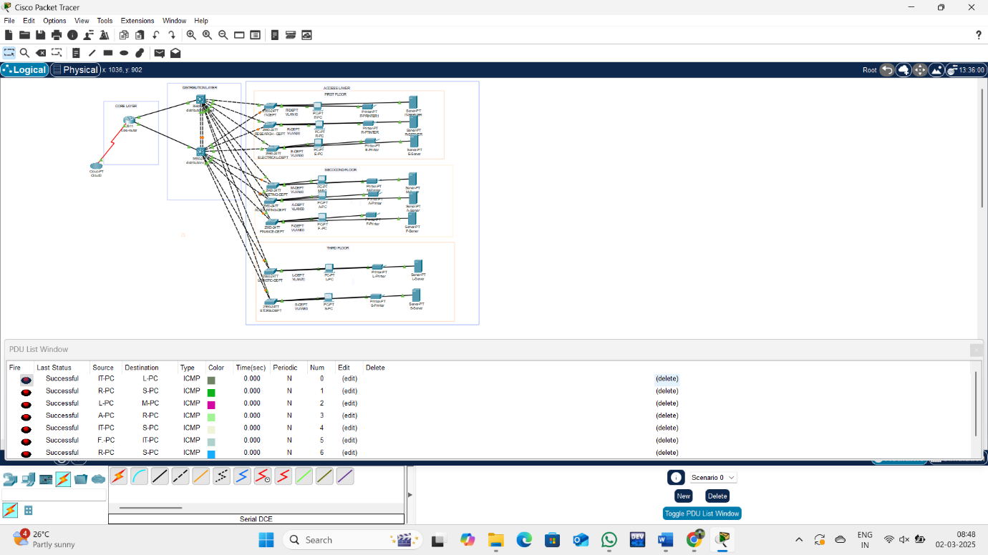

**Result:** Therefore stimulating of companies network designing has been successfully done using packet tracer.